PF LAB

ASSIGNMENT 6

# NAME: Mehreen Fatima

# SAP ID:63255

# QUESTION 1:

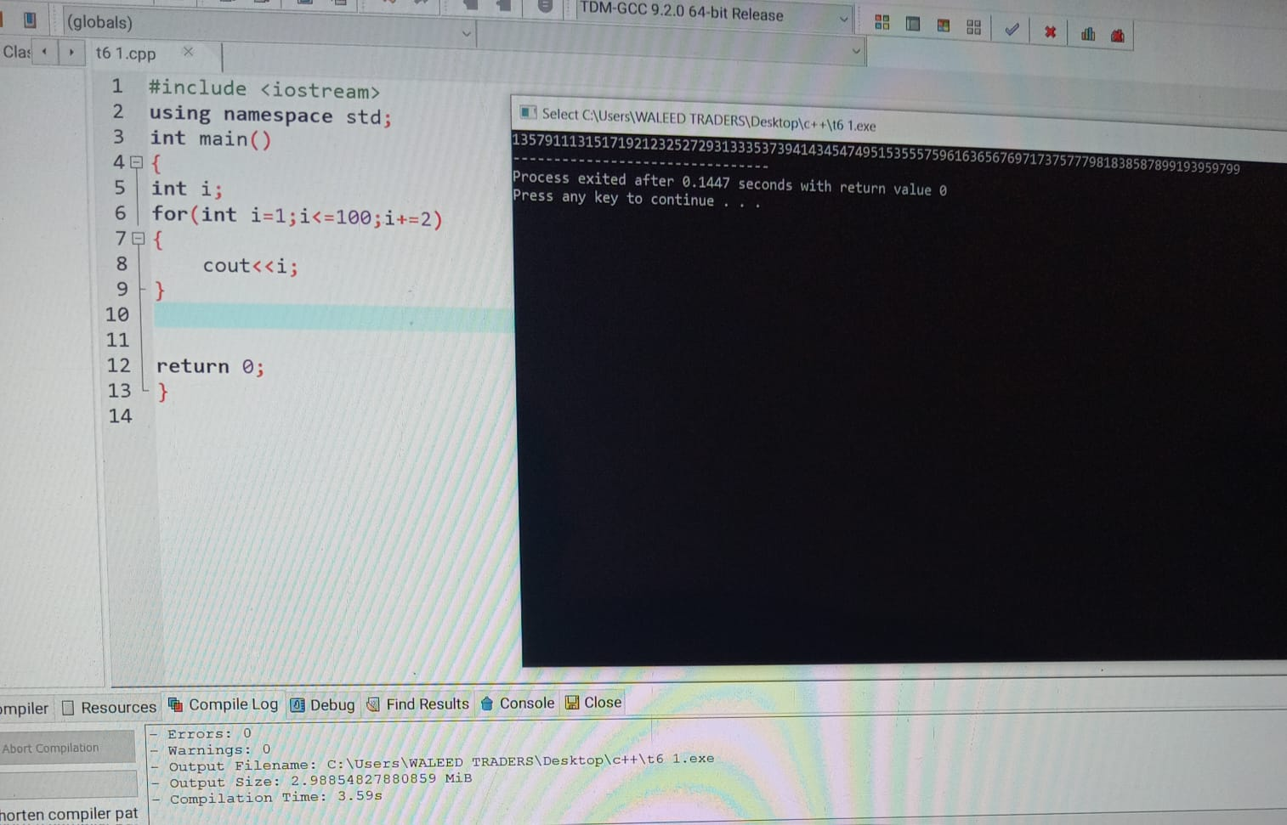

# QUESTION 2:

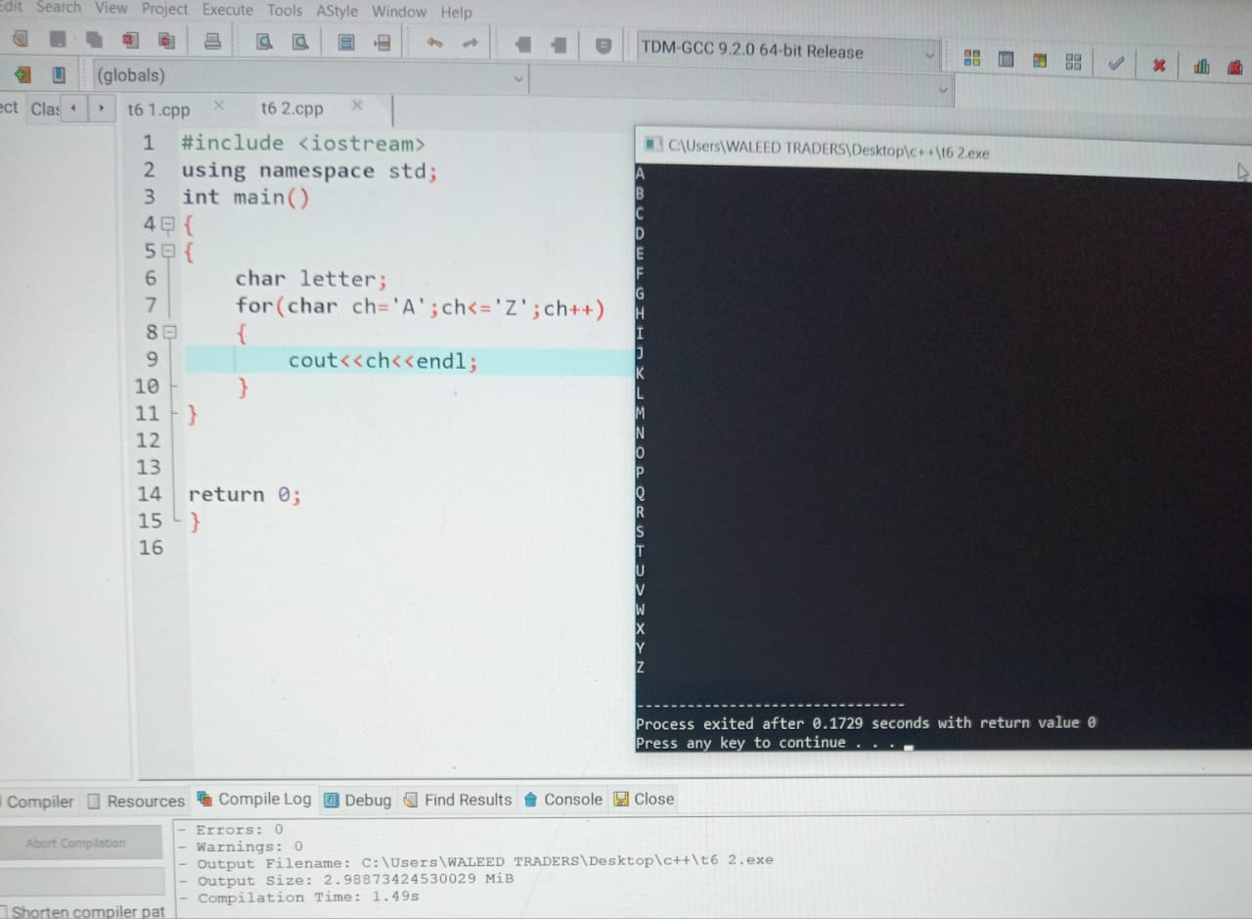

# QUESTION 3:

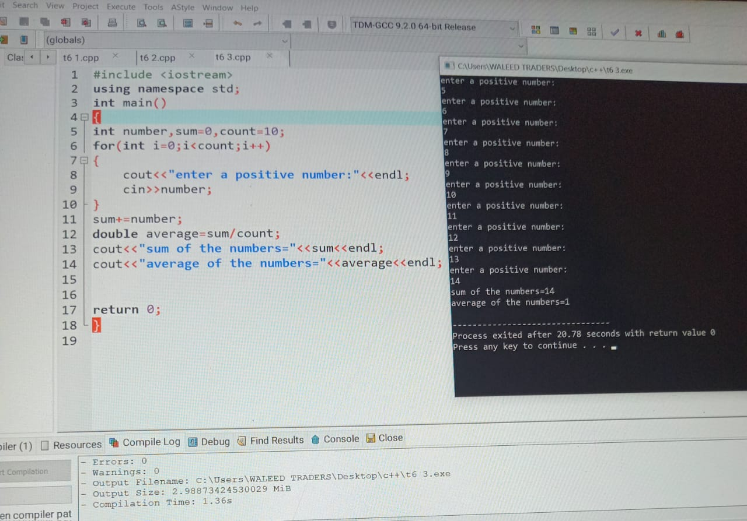

# QUESTION 4:

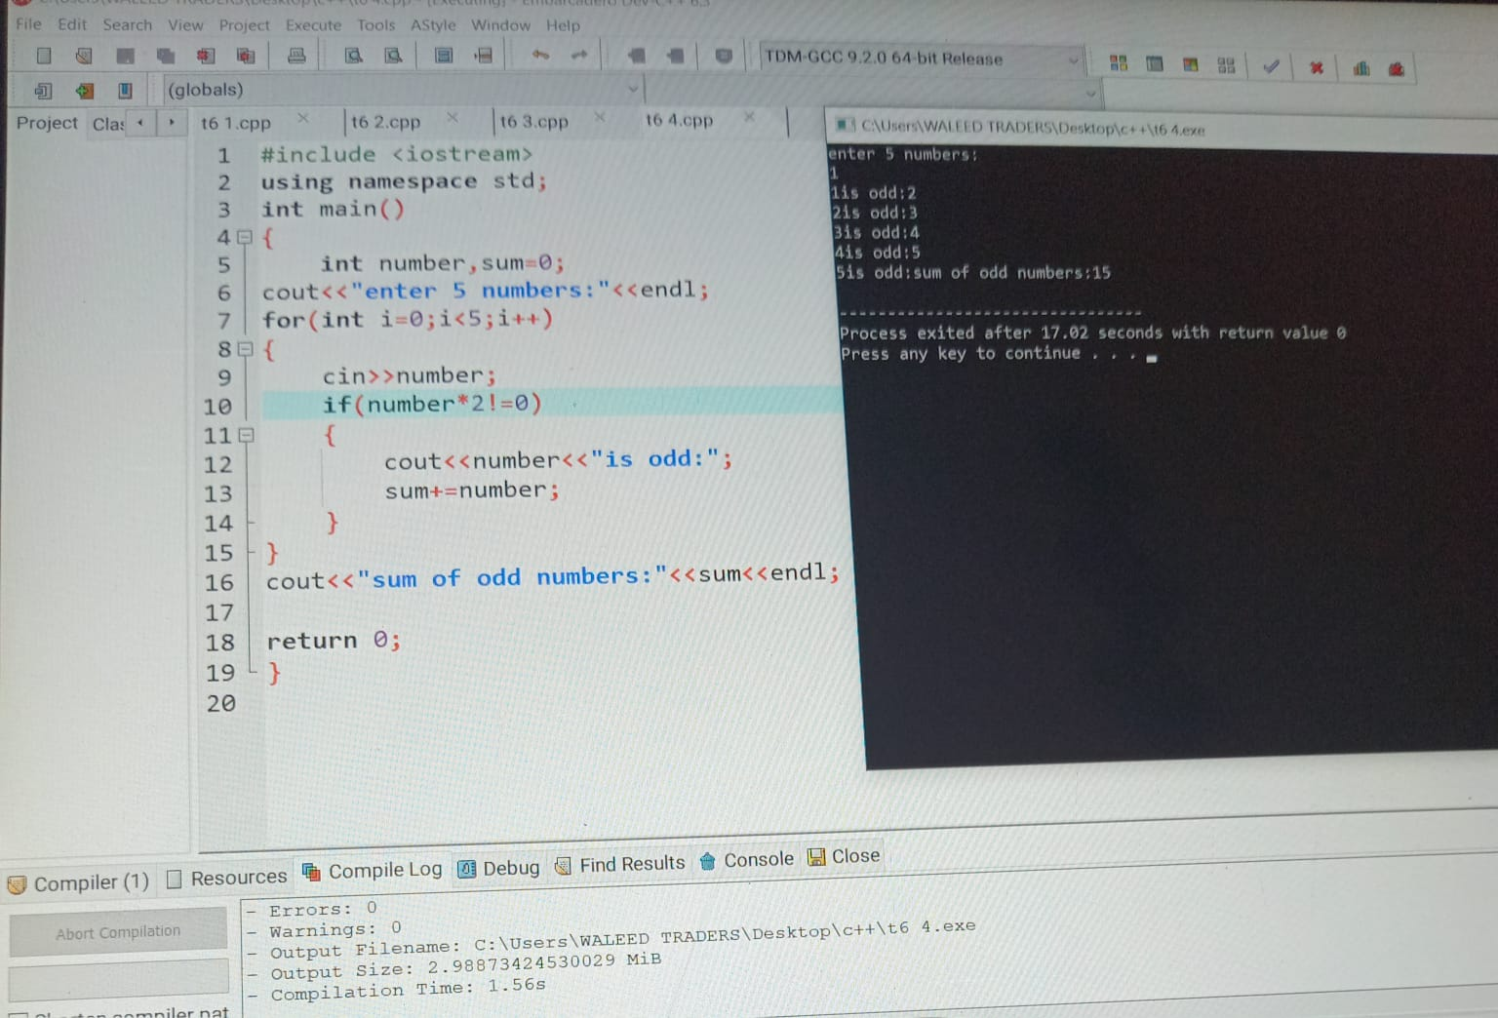

# QUESTION 5:

